Task 5:
Transaction-Based Payment Simulation

Aim
To simulate an online payment process using transactional management in Spring Boot, ensuring atomic operations where user balance is deducted and merchant balance is credited using COMMIT on success and ROLLBACK on failure.

Algorithm
- Create an Account Entity with fields: id, name, balance, type (USER/MERCHANT)
- Configure database and JPA properties
- Create a repository interface extending JpaRepository
- Create a service layer with a transactional method
- Deduct amount from user account
- Add amount to merchant account
- If both operations succeed → COMMIT
- If any failure occurs → ROLLBACK
- Create a runner class to simulate transaction execution

Program
Account Entity
import jakarta.persistence.*;
@Entity
public class Account {
@Id
@GeneratedValue(strategy = GenerationType.IDENTITY)
private Long id;
private String name;
private double balance;
private String type; // USER or MERCHANT
public Account() {}
public Account(String name, double balance, String type) {
this.name = name;
this.balance = balance;
this.type = type;
}
// Getters and Setters
public Long getId() { return id; }
public double getBalance() { return balance; }
public void setBalance(double balance) { this.balance = balance; }
public String getName() { return name; }
}

Repository Interface
import org.springframework.data.jpa.repository.JpaRepository;
public interface AccountRepository extends JpaRepository<Account, Long> {
}

Service Layer (Transactional Logic)
import org.springframework.beans.factory.annotation.Autowired;
import org.springframework.stereotype.Service;
import org.springframework.transaction.annotation.Transactional;
@Service
public class PaymentService {
@Autowired
private AccountRepository repo;
@Transactional
public void transferMoney(Long userId, Long merchantId, double amount) {
Account user = repo.findById(userId)
.orElseThrow(() -> new RuntimeException("User not found"));
Account merchant = repo.findById(merchantId)
.orElseThrow(() -> new RuntimeException("Merchant not found"));
// Deduct from user
if (user.getBalance() < amount) {
throw new RuntimeException("Insufficient balance");
}
user.setBalance(user.getBalance() - amount);
// Simulate failure (optional testing)
// if (true) throw new RuntimeException("Transaction Failed");
// Add to merchant
merchant.setBalance(merchant.getBalance() + amount);
repo.save(user);
repo.save(merchant);
}
}

Main Application (Runner)
import org.springframework.beans.factory.annotation.Autowired;
import org.springframework.boot.CommandLineRunner;
import org.springframework.stereotype.Component;
@Component
public class PaymentRunner implements CommandLineRunner {
@Autowired
private PaymentService service;
@Autowired
private AccountRepository repo;
@Override
public void run(String... args) throws Exception {
// Create sample accounts
Account user = new Account("Alice", 5000, "USER");
Account merchant = new Account("Amazon", 10000, "MERCHANT");
repo.save(user);
repo.save(merchant);
try {
service.transferMoney(user.getId(), merchant.getId(), 1000);
System.out.println("Transaction Successful (COMMIT)");
} catch (Exception e) {
System.out.println("Transaction Failed (ROLLBACK)");
}
// Display updated balances
repo.findAll().forEach(acc ->
System.out.println(acc.getName() + " Balance: " + acc.getBalance())
);
}
}

Output
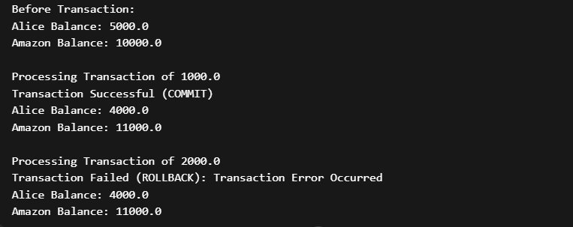

Result
The transaction-based payment simulation was successfully implemented using Spring Boot. The system ensures atomicity using transactional management, where either all operations are committed or none are applied, maintaining data consistency similar to real-world banking and digital payment systems.

